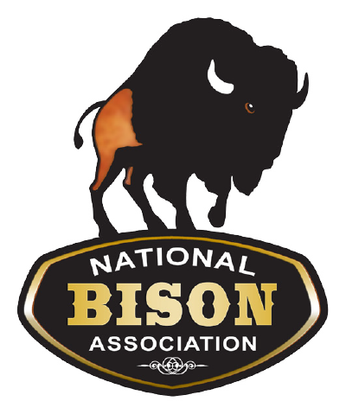
NBA 2018 Roaming to Success Bison
Art Contest
ENTRY AND RELEASE FORM

Please affix this form securely to your submission and remember to write your name on the back of your entry!
Please submit this form with your entry.
All entries are due by January 2nd.
Winners will be announced on January 15th.

Artist’s Name:

Age: Grade:
School/Tribe:
Parent/Guardian: Home Address:
Home Phone:

National Bison Association Artwork Copyright Release

The above named Artist hereby warrants being the legal copyright owner of the artwork submitted to the NBA for the 2018 Art Contest and hereby grants permission to The National Bison Association and his/her/their Art Reproduction Company of choice to make reproductions of the Work in any size or quantity for its purposes.

Artist's Signature:

Date: ________________

Parent/Guardian Signature:

Date:

