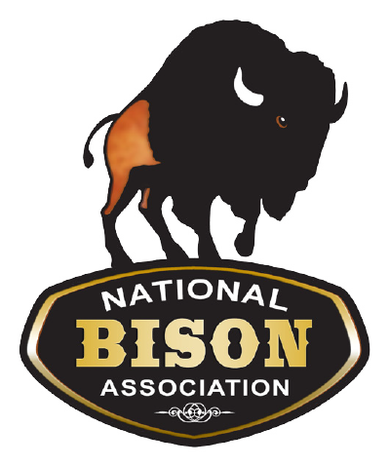
NBA 2022 Foraging Ahead
Bison Photography Contest
Entry and Release Form

Please return this form with your entry. All entries are due by January 8th. Winners will be announced at the NBA Winter Conference. Need not be present to win. Form can be emailed to jim@bisoncentral.com.

Photographers Name:
Home City/State:
Home Phone:

Email: __________________________________

For youth entries:
Age:_______
Parent/Guardian Name: _____________________________________________
National Bison Association Photo Copyright Release
The above named Photographer hereby warrants being the legal copyright owner of the photograph(s) submitted to the NBA for the 2022 Photo Contest and hereby grants permission to The National Bison Association and the Texas Bison association, and his/her/their Photo Laboratory of choice to make reproductions of the Work in any size or quantity for future promotional purposes.

Photographer's Signature:

Date:

Parent/Guardian Signature:

Date:

